**SESSION 2015**

**SELECTION INTERNATIONALE**

**ECOLE NORMALE SUPERIEURE**

**Sujet Discipline Principale**

**Biologie**

**Durée : 3h**

**Sujet 1**

**Genetic and Evolution**

**Durée: 1h30**

After reading the paper “Scaling, Selection, and Evolutionary Dynamics of the Mitotic Spindle”, please answer 4 of the 5 following questions:

1. What problem is addressed and what is its significance for biological research?

2. Describe three of the several technical approaches that are used. How do they tackle the main objective of the study?

3. What is the main claim that the authors make regarding the mode of natural selection causing the evolution of the mitotic spindle? Describe an alternative method that could lead to a similar conclusion?

4. The authors assume that evolutionary dynamics mostly occurs from mutational input. What are the potential complications if the mitotic spindle evolved also from standing genetic diversity?

5. Nematodes, as most organisms, live in spatially and temporally heterogeneous environments. Describe an ecological scenario where selection could result in the evolution of the mitotic spindle that does not involve individual selection. How would such a scenario support and/or conflict with the conclusions of the study?

**Sujet 2**

**Cell Biology**

**Durée: 1h30**

Research in cellular mechanotransduction often focuses on how extracellular physical forces are converted into chemical signals at the cell surface. However, mechanical forces that are exerted on surface-adhesion receptors, such as integrins and cadherins, are also channelled along cytoskeletal filaments and concentrated at distant sites in the cytoplasm and nucleus. In this problem, we explore the molecular mechanisms by which forces can be transmitted through the cell and might act at a distance to induce mechanochemical conversion in the nucleus and alter gene activities.

**Question 1: what are the different components of the cytoskeleton? Explain briefly their different roles.**

The src kinase is a kinase known to respond to mechanical cues. Src can regulate integrin–cytoskeleton interaction, and cause dissolution of actin stress fibres and the release of mechanical tensile stress. To assess the response of proteins to mechanical stress, we designed a src FRET biosensor, according to figure 1.

**Question 2: from figure 1, explain the principle of Fluorescence Resonance Energy Transfer (FRET). Explain the principle of the Src biosensor.**

**Question 3: what alternatives to FRET-biosensors can you name to probe the activation of proteins upon different stimuli in living cells?**

**Question 4: according to figure 2, what hypothesis could you set for the activation of src kinase upon mechanical stress compared to EGF-induced activation?**

A stable connection between the nucleus and cytoskeleton is required for a wide range of physiological functions such as cell migration or nuclear positioning. Two recently discovered major molecular components involved in nucleo-cytoskeletal coupling are nesprin and SUN proteins, nuclear envelope trans-membrane protein families that form a bridge across the nuclear envelope. SUN1 and SUN2 are retained at the inner nuclear membrane by their interaction with lamins, nuclear pore complex proteins, and the nuclear interior, whereas their conserved C-terminal SUN domain extends into the perinu-clear space. Here, they interact with the highly conserved C-terminal KASH domain of nesprins located at the nuclear envelope.

**Question 5: from figure 3 and 4, elaborate hypothesis of potential interactions between mechanical stimuli and the regulation of genetic expression**



**Figure 1: a**, The Src reporter is composed of CFP, the SH2 domain, a flexible linker, the Src substrate peptide and YFP. **b**, The cartoon illustrates the FRET effect of the Src reporter upon the actions of Src kinase or phosphatase. **c**, Emission spectra of the Src reporter before (black) and after (red) phosphorylation by Src. **d**, *In vitro* emission ratio changes (mean ± s.d.) of the Src reporter in response to Src and other kinases.



**Figure 2:** Rapid Src activation in response to localized mechanical stress. (A) A 4.5-μm RGD-coated ferromagnetic bead was attached to the apical surface of the cell (Left Upper, black dot is the bead) for 15 min to allow integrin clustering and formation of focal adhesions around the bead. The bead was magnetized horizontally and subjected to a vertical magnetic field (step function) that applies a mechanical stress σ (specific torque = 17.5 Pa) to the cell. A genetically encoded, CFP-YFP cytosolic Src reporter was transfected into the smooth muscle cells. The cytosolic Src reporter was uniformly distributed in the cytoplasm (Left Lower, YFP). The stress application induced rapid changes (<0.3 s) in FRET of the Src reporter at discrete, distant sites in the cytoplasm (see Insets) (focal plane is ≈1 μm above cell base), indicating rapid Src activation. Images are scaled, and regions of large FRET changes (strong Src activity) are shown in red. The black arrow indicates bead movement direction. (Scale bar, 10 μm.) (B) Time course of normalized CFP/YFP emission ratio, an index of Src activation in response to mechanical or soluble growth factor EGF stimulation. n = 12 cells for +σ; n = 8 cells for +EGF. Error bars represent SEM. (C) Time course of CFP/YFP emission ratio in response to EGF in a representative cell. EGF was locally released on top of the cell apical surface (<1 μm above) by using a micropipette (25 μm in diameter; top right of the Inset) (Scale bar, 20 μm) that was controlled by a micromanipulator and CellTram Vario. EGF (50 ng/ml) was released at a flow rate of 2 × 104 μm3/ms continuously for 5 min. Because the diffusion coefficient of a protein in water is ≈ 100 μm2/s, it takes ≈10 ms for EGF to reach the cell apical surface, and local EGF concentration at the cell apical surface is ≈ 40 ng/ml. (D) Time course of average Src activation from eight different cells after EGF treatment as in C. Error bars represent SEM. (E) Src activation at different cytoplasmic sites. At every 1 μm away from the bead, the emission ratio image after mechanical stimulation was compared pixel-by-pixel with that before mechanical stimulation. (F) The number of activated pixels (percentage of total activated pixels) at a given time versus distance from the bead after 0.3 s and 2.7 s of mechanical stimulation. Maximum number of Src activation was observed at ≈15 μm away from the bead. Note that the spatial distribution of Src activation but not the intensity of Src activation is summarized here. n = 8 cells. Error bars represent SEM.

**Figure 3**: Phase contrast (A and B) and fluorescence (C) images of a fibroblast labeled with Hoechst 33342 nuclear stain (blue) and MitroTracker Green mitochondrial stain (green). A microneedle was inserted into the cytoskeleton at a defined distance from the nucleus and subsequently moved toward the cell periphery. (D) The average displacement over the cell area is represented in controlled conditions (mcherry) and knock out -/- for the KASH domain of nesprin proteins (DN KASH).

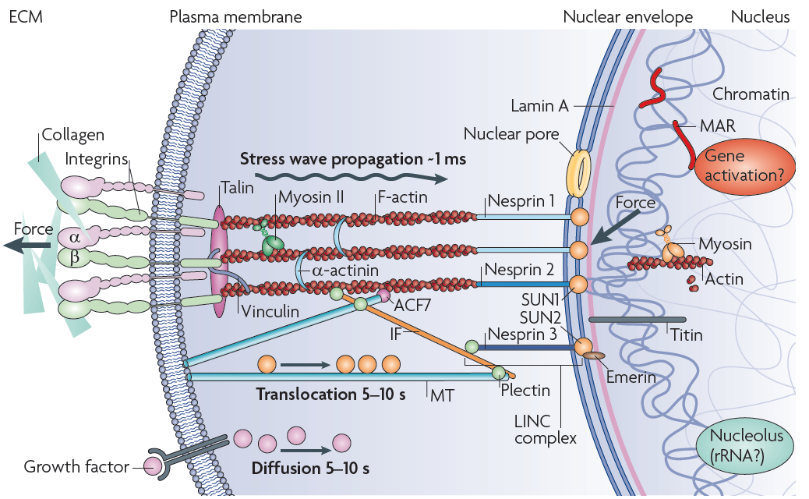

**Figure 4**: A local force applied to integrins through the extracellular matrix (ECM) is concentrated at focal adhesions and channelled to filamentous (F)-actin, which is bundled by α-actinin and made tense by myosin II, which generates prestress. F-actins are connected to microtubules (MTs) through actin-crosslinking factor 7 (ACF7), and to intermediate filaments (IFs) through plectin 1. Plectin 1 also connects IFs with MTs and IFs with nesprin 3 on the outer nuclear membrane. Nesprin 1 and nesprin 2 connect F-actin to the inner nuclear membrane protein SUN1; nesprin 3 connects plectin 1 to SUN1 and SUN2. Owing to cytoplasmic viscoelasticity, force propagation from the ECM to the nucleus might take up to ̴̴̴1 ms. The sun proteins connect to the lamins that form the lamina and nuclear scaffold, which attaches to chromatin and DNA (for example, through matrix attachment regions (MARs)). Nuclear actin and myosin (and nuclear titin) might help to form the nuclear scaffold, control gene positioning and regulate nuclear prestress. The force channelled into the nuclear scaffold might directly affect gene activation within milliseconds of surface deformation. By contrast, it takes seconds for growth factors to alter nuclear functions by eliciting chemical cascades of signalling, which are mediated by motor-based translocation or chemical diffusion.